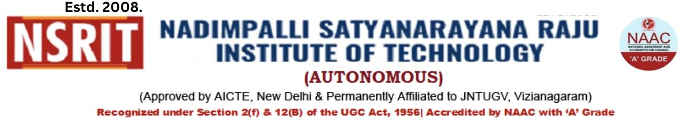

Office of Controller of Examination

Feb 19, 2026

This is to inform all the students of B.Tech admitted under Autonomous Regulation 2020 Rev 1.0 admitted during 2022-23 Academic year and Re admitted students of Autonomous Regulation 2020, that they need to pay a fee for PROVISIONAL CERTIFICATE AND CMM as per the instructions furnished below.

PC and CMM fee | Last Date | Rs.
Last Date for Fee Payment | March 09, 2026 | 2,700/-
Last Date With Fine of Rs 500 | March 11, 2026

CONTROLLER OF EXAMINATIONS | PRINCIPAL

Copy to: (a) HoDs with a request to inform the students, mentor and exam cell coordinator
(b) Accounts
(c) Website / Notice Board
(d) File, Office of the Controller of Examinations

